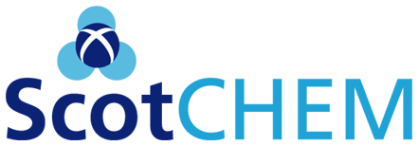

Application for Scottish Funding Council supported PEER (Pools Engagement in European Research) or PECRE (Postgraduate and Early Career Researcher Exchanges) Award

Please refer to the attached notes for eligibility and conditions of award. The Model Case studies, also attached, may be helpful to you in making your application.

Your Name, E-mail Address and University:

Your Status:

Your Supervisor (applicable to PhD Students and Post-docs):

Year of Study and Studentship Funding Body (PhD Students):

Collaborating Institution(s)/Company:

Name of Host/Visiting Research Leader/Collaborator:

Purpose of Award (300 words max):

Potential Outcomes and Benefits (300 words max):

PEER: How will you engage with the EU framework process? e.g. establishing network connections; showcase your skills and capabilities; participating in specific networking activities; developing proposals and applying for European funding under the Framework Programme.

PECRE: Identify any new skills or techniques that may be acquired and the possible longer term career benefits that could results from the exchange

PEER/PECRE: Outline the benefits to your School/Department that may arise and the prospects for sustained research activity

Estimated Costs (please specify travel, subsistence or other):

Provisional Dates of Exchange (to be completed by 31/12/2019):
IMPORTANT: Applications should be submitted by email to Carolyn Busby
cmb20@st-andrews.ac.uk by 12/10/2018. In the case of PhD students and Post-docs, an accompanying letter of support from your supervisor should be included. You should receive a confirmation e-mail shortly after submission. We will notify you of the results within 6 weeks of the deadline.

Please submit a brief scientific report (2 pages A4) within one month of the completion of the exchange and remember to acknowledge your SFC award in publications or other outputs associated with the exchange.

Pools Engagement in European Research (PEER)

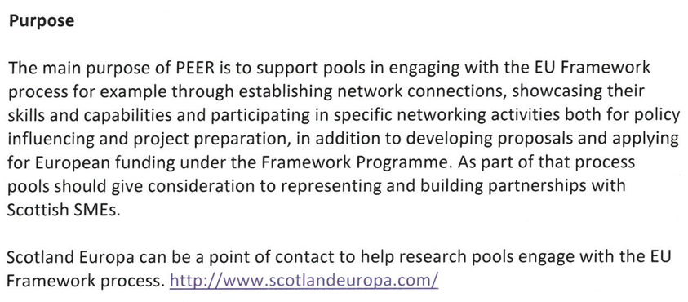

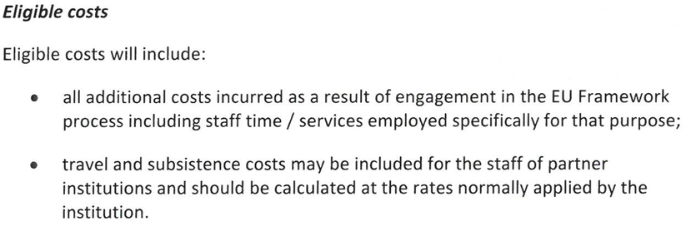

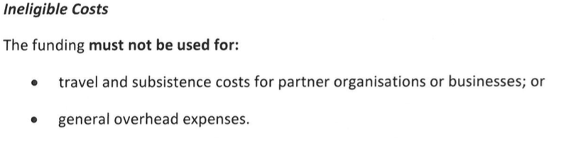
Postgraduate /Early Career Exchanges (PECRE)

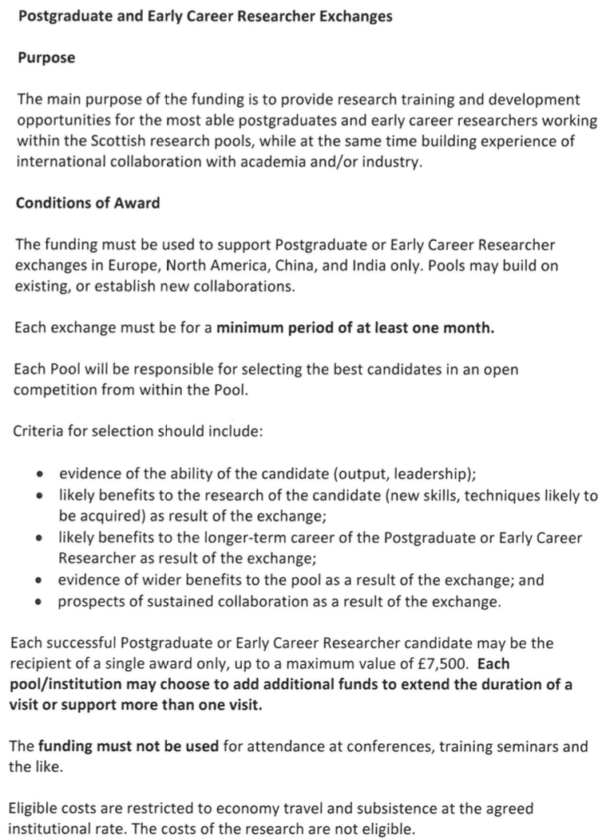

MODEL CASE STUDY 1

I am an early career researcher in WestCHEM, the recipient of a Fellowship. My exchange was to the Institut Català d'Investigació Química (ICIQ) in Tarragona, Spain, a leading research centre strong in Energy, Supramolecular Chemistry, and Catalysis. The primary aim of my exchange was to enable me to work with a world leader in computational modelling of catalysis, on a topic closely related to my experimental-focussed research in the study of nickel catalysis. During the two months of the exchange I learnt a significant amount of knowledge about how to design, run, and interpret complex theoretical calculations that enabled me to understand processes that occur in experimental reactions. A reciprocal visit to WestCHEM by the Spanish professor took place on my return to Glasgow, funded by the University Global Engagements Fund. The collaboration is on-going and is currently finalizing work for a manuscript that will be submitted to a high-impact journal such as J. Am. Chem. Soc. During my time in Spain I also held informative networking meetings with several other academics at different institutions. This knowledge-broadening trip has undoubtedly helped to strengthen my research development and hopefully the new European collaborations made will continue to benefit me in the coming years.

MODEL CASE STUDY 2

The objective of the exchange was to develop a multidisciplinary research collaboration leading to the submission of a European H2020 proposal. Towards this objective, I interacted closely with chemistry academics at Strathclyde, and an academic within the Electronic and Electrical Engineering department. As the proposal involved multidisciplinary aspects spanning analytical chemistry, polymer chemistry and image processing, close interactions with their respective research groups ensured the drafting of an effective document. Further, I gained valuable information about the University’s Researcher Development Programme and various researcher training that were incorporated into the proposal. The combined input gained through these interactions led to the proposal submission for a H2020-MSCA-IF-2016 - Standard European Fellowship. Apart from the submission of the proposal, the exchange visit helped me get an insight into research activities carried out in the hosts’ research groups and their relevance to research objectives at my own institute based in India. This has enhanced the possibilities for a future mutually beneficial long-term research collaboration between WestCHEM and the Indian institute.

MODEL CASE STUDY 3

As part of my PhD project at Strathclyde University, I undertook a PECRE-funded trip to visit and research in the City University of New York’s’ (CUNY) new Advanced Scientific Research Centre (ASRC) for two months. The ASRC is a brand new facility that will bring together the scientific departments in the surrounding area of New York. It has outstanding world class facilities and strongly promotes the idea of collaboration. It is a strategic aim of Strathclyde University to establish strong connections with CUNY. My work was to focus on the designing and controlling of enzymatic systems for the production of tripeptides. During the visit I was able to produce exciting data, which most significantly led to stabilising the formation of the peptides for a sustained period of time. These data subsequently formed the cornerstone of a submitted joint Strathclyde-CUNY paper that was accepted for publication in the high impact journal Advanced Materials.

