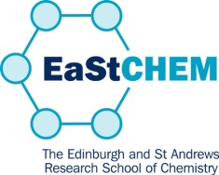
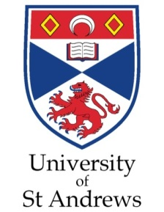

Academic Paper Writing
(EaStCHEM course for chemists
sponsored by ScotCHEM)

Thursday 1st September 2022

11.00 -11.10 hrs Welcome and Introduction
Prof Marialuisa Aliotta, University of Edinburgh

11.10 -12.00 hrs How to get your work published
Prof Russell Morris, University of St Andrews

12.00 -13.00 hrs How to write a scientific paper
Prof Marialuisa Aliotta

13.00 -14.00 hrs Break for Lunch

14.00 -15.40 hrs How to write a scientific paper
Prof Marialuisa Aliotta

15.40 -16.00 hrs Questions, answers and closing remarks

****************

