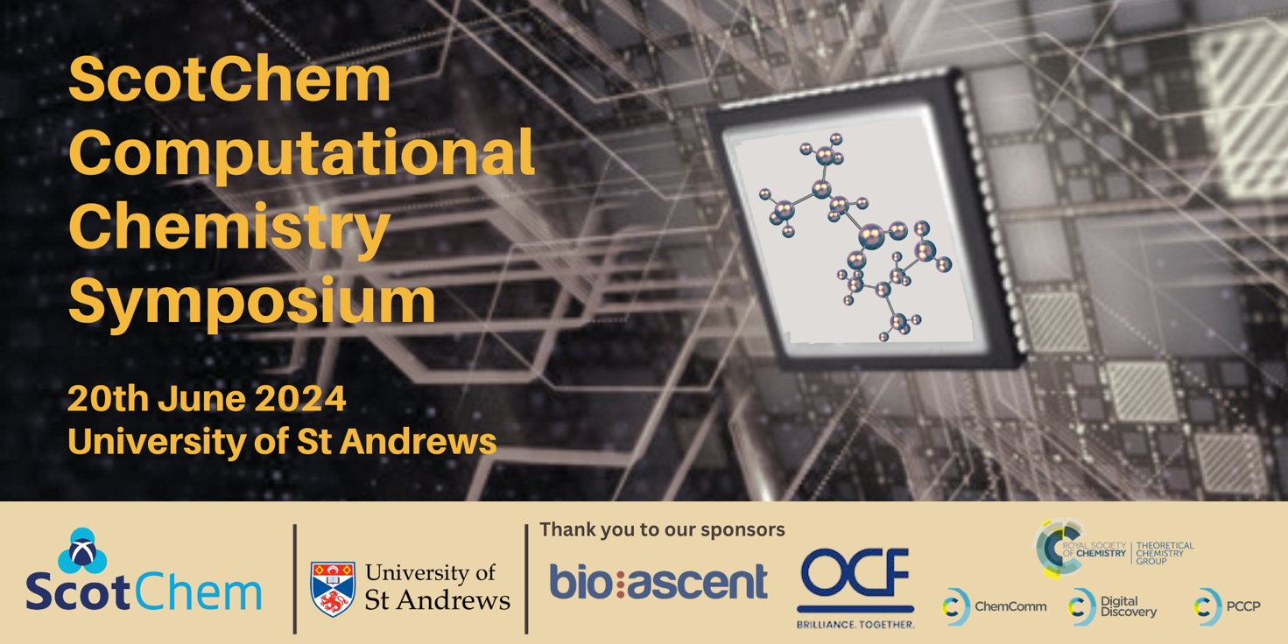

Call for Poster Abstracts

Thank you for expressing interest in our Computational Chemistry Symposium! We will be hosting a range of speakers from both industry and academia, with a plenary talk from Dr Christina Trujilo, University of Manchester. There will also be plenty of opportunities for networking.

We are keen to invite poster contributions from all-year PhDs and postdocs. Prizes will be awarded for the best posters.

This symposium is free to attend. For registration, visit our Eventbrite page:
https://www.eventbrite.co.uk/e/scotchem-computational-chemistry-symposium-2024-tickets-879554048837

Guidelines for Poster Abstracts

Please use the template on the following page and these guidelines for your abstract(s):

- Please use this format for the abstract file name: Surname-Name_CompChem2024_P
- Use a separate file for each abstract if submitting on behalf of others
- One A4 page
- Left margin 4cm, right margin 2.5cm, top margin 2.5cm, bottom margin 2.5cm
- Single line space
- Font: Arial
- Title in 14-point bold, centred
- Authors and institution details beneath the title, in 11-point, centred
- Abstract text 12-point, justified
- References in 10-point font, numbered with Arabic numerals
- Word document and not pdf
- Please note posters must be in portrait format, size A0

Please e-mail all abstracts by 5pm on 25th May 2024 to:
compscot24@st-andrews.ac.uk

Many thanks,

ScotChem

The title goes here

A. Author, B. Author, C. Author and D. Author

Institution address

Text of abstract Text of abstract Text of abstract Text of abstract Text of abstract Text of abstract Text of abstract Text of abstract Text of abstract Text of abstract Text of abstract Text of abstract Text of abstract Text of abstract Text of abstract Text of abstract Text of abstract Text of abstract Text of abstract Text of abstract Text of abstract Text of abstract Text of abstract Text of abstract Text of abstract Text of abstract Text of abstract Text of abstract Text of abstract Text of abstract Text of abstract Text of abstract Text of abstract Text of abstract Text of abstract

Schemes/Figures centered

Text of abstract Text of abstract Text of abstract Text of abstract Text of abstract Text of abstract Text of abstract Text of abstract Text of abstract Text of abstract Text of abstract Text of abstract Text of abstract Text of abstract Text of abstract Text of abstract Text of abstract Text of abstract Text of abstract Text of abstract Text of abstract Text of abstract Text of abstract Text of abstract Text of abstract Text of abstract Text of abstract Text of abstract Text of abstract Text of abstract Text of abstract Text of abstract Text of abstract Text of abstract Text of abstract Text of abstract Text of abstract Text of abstract Text of abstract Text of abstract Text of abstract Text of abstract Text of abstract Text of abstract Text of abstract Text of abstract Text of abstract Text of abstract Text of abstract Text of abstract Text of abstract Text of abstract Text of abstract Text of abstract Text of abstract Text of abstract Text of abstract Text of abstract Text of abstract Text of abstract Text of abstract Text of abstract Text of abstract Text of abstract Text of abstract

References
- Author, B. Author, C. Author and D. Author, Journal Title, year, vol, pages.
- Author, B. Author, C. Author and D. Author, Journal Title, year, vol, pages.
- Author, B. Author, C. Author and D. Author, Journal Title, year, vol, pages.

